AI Assisted Coding End Lab Exam 20.11.2025 CSB01 and CSB02
📘 SET 1
Q1. Prompt Engineering (Scenario)
Your company is building an invoice summarizer. You must write a prompt that instructs AI to generate a Python function that extracts total amount, tax, and invoice number from a text paragraph. Refine the prompt until extraction accuracy improves.
(Include docstrings, comments, and test cases for the extracted function.)
Q2. DB/SQL Scenario 2 — Online Course Enrollment System
An e-learning platform needs a backend database for course registrations.
Task
With AI assistance:
- Create tables for:
  - Students
  - Courses
  - Enrollments
- Write SQL queries to:
  - Enroll a student in a course
  - Generate a list of students enrolled in a specific course
  - Count total enrollments per course
- Provide schema documentation, inline comments, and test cases using sample entries.

📘 SET 2
Q1. Advanced Prompt Engineering – Few-shot (Scenario)
You are developing an AI assistant for school children. Create a few-shot prompt that helps AI generate Python code for 3 ways to check if a number is even or odd (modulo, bitwise, repeated subtraction).
(Include docstrings + comments + test cases for the output program.)
Q2. Data Structures (Scenario)
A hospital management system needs to maintain a queue of patients waiting for consultation. Implement a Queue data structure using Python with enqueue, dequeue, and peek operations.
(Add docs + comments + tests.)
📘 SET 3
Q1. AI-Based Code Completion (Scenario)
A smart attendance app stores student details. Using AI code suggestions, complete a partially written Python class Student with methods to:
- mark attendance
- calculate attendance percentage
(Add docs + comments + tests.)
Q2. Web Frontend (Scenario)
A startup wants a responsive employee ID card UI for mobile and web. Generate HTML + CSS + JS using AI assistance. (Include comments + simple UI test scenarios.)

📘 SET 4
Q1. Data Structures (Scenario)
A food delivery app stores customers' recent searches. Implement a Stack where latest search appears first. (Include documentation + test cases.)
Q2. Algorithms (Scenario)
A logistics company wants to sort parcel weights quickly. Use AI to implement Merge Sort to sort millions of weight entries. (Add docs + comments + tests.)

📘 SET 5
Q1. Prompt Engineering – Zero-shot (Scenario)
Your manager asks you to generate code that finds the highest-rated product from a list of ratings. Write an effective zero-shot prompt to achieve this.
(Include docs + comments + tests in the resulting code.)
Q2. Database Design (Scenario)
A book shop wants a digital store. Use AI to design database tables for books, authors, and sales and generate SQL queries to:
- list best-selling books
- add a new author
- update stock
(Add comments + test queries.)

📘 SET 6
Q1. AI Code Completion (Scenario)
A company payroll system requires an Employee_Payroll class that calculates salary, PF, and deductions. Use AI-assisted completion to finish the class.
(Include docs, comments, and test cases.)

Q2. Algorithms (Scenario)

A warehouse search tool needs both Linear Search and Binary Search comparisons.
Implement both using AI assistance.
(Document + test.)

📘 SET 7

Q1. Data Processing (Scenario)

A bank gives you customer CSV records containing missing values and duplicate entries.
Write AI-assisted code to:
- clean missing values
- remove duplicates
- standardize phone numbers
(Include docs + comments + test cases.)

Q2. Algorithms (Scenario)

A gaming leaderboard requires sorting players by score. Implement Quick Sort using AI help.
(Include documentation + tests.)

📘 SET 8
Q1. Web Frontend (Scenario)
A startup needs a responsive login page with JavaScript validation for incorrect passwords. Generate HTML + CSS + JS using AI.
(Include comments + validation test scenarios.)
Q2. Data Structures (Scenario)
A social media platform stores user posts in chronological order.
Implement a Linked List to insert and display posts.
(Add docs + tests.)

📘 SET 9
Q1. Prompt Engineering (Scenario)
You must generate a Python function to calculate monthly loan EMI for a banking chatbot.
Design and refine the prompt.
(Add documentation + test cases for the EMI function.)
Q2. SQL Generation (Scenario)
A university wants a system to track course registrations. Use AI to generate:
- schema for students, courses, registrations
- Insert Random Data
- SQL queries to enroll & list registrations
(Add comments + test cases with sample data.)

📘 SET 10
Q1. Prompt Design (Scenario)
Your task is to design a prompt that makes AI generate optimized matrix multiplication code for large matrices. Improve the prompt iteratively. (Add docstrings + tests to generated code.)
Q2. DB/SQL Scenario 1 — Restaurant Management System
A restaurant wants to build a digital order management system.
Task
Using AI assistance:
- Design the database schema with tables:
  - MenuItems
  - Orders
  - OrderItems
- Generate SQL queries to:
  - Add a new menu item
  - Place an order with multiple items
  - Retrieve today’s total sales
- Add documentation, comments, and test cases using sample data inserts and expected results.
Task1
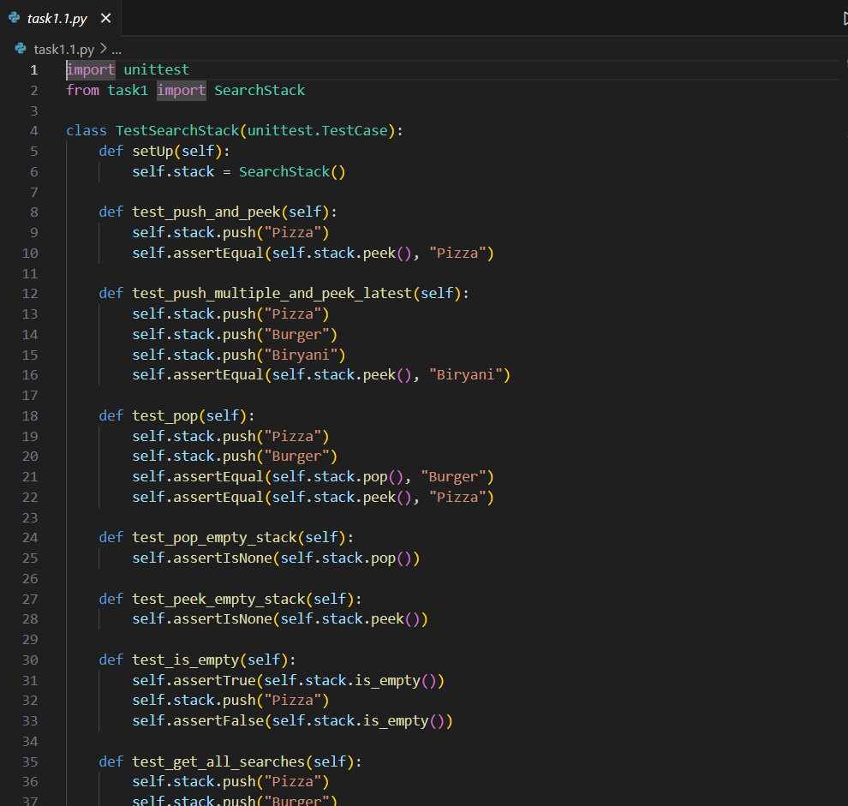
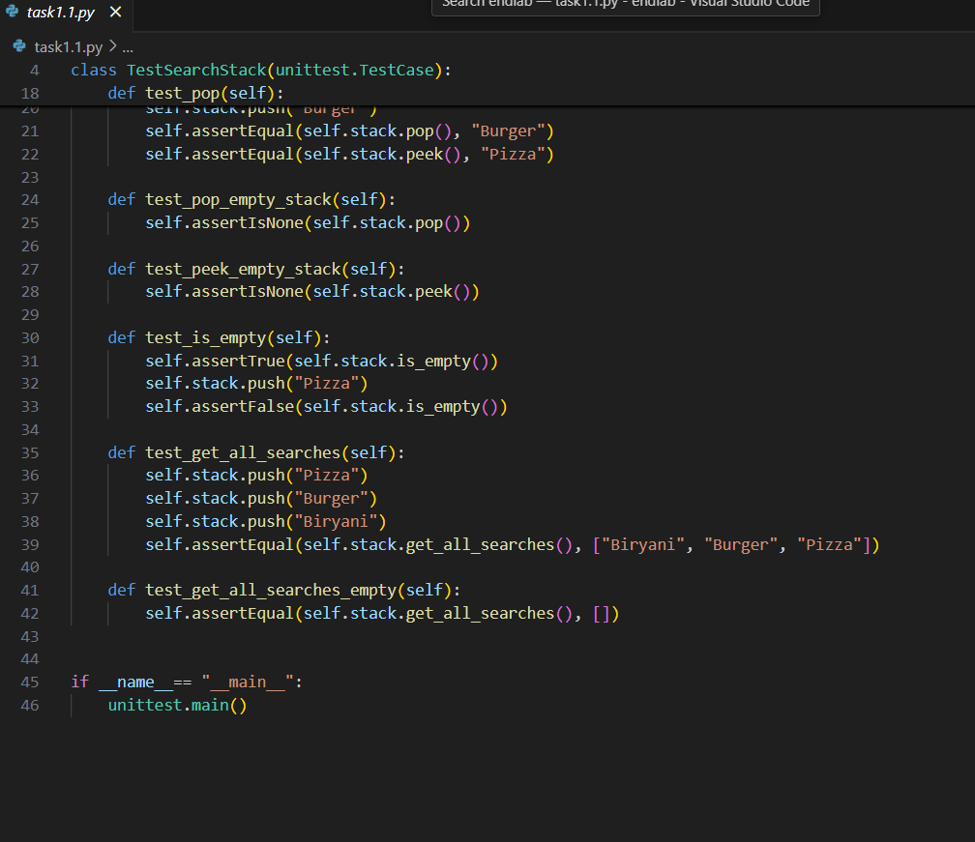
Task1.1:
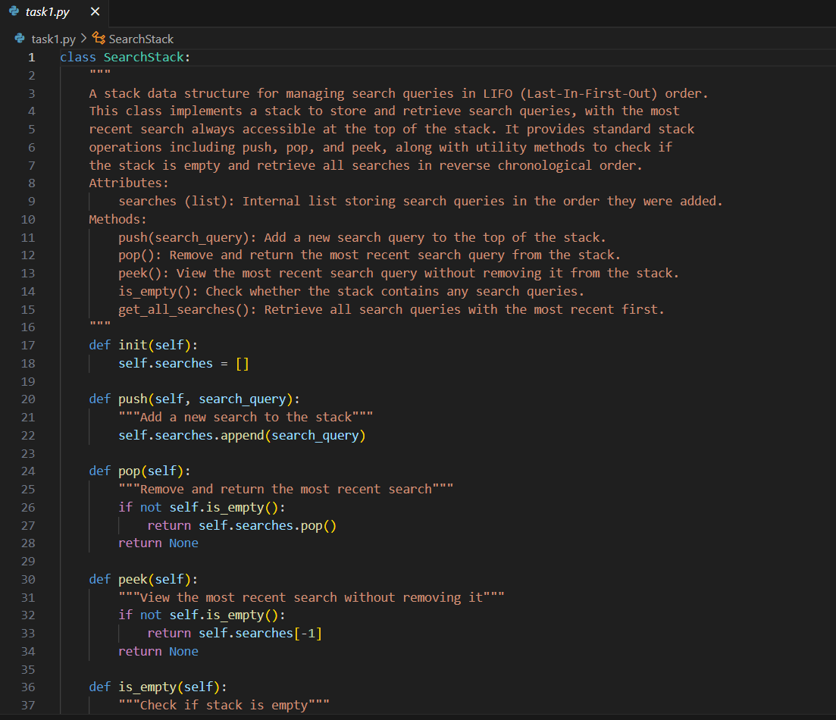
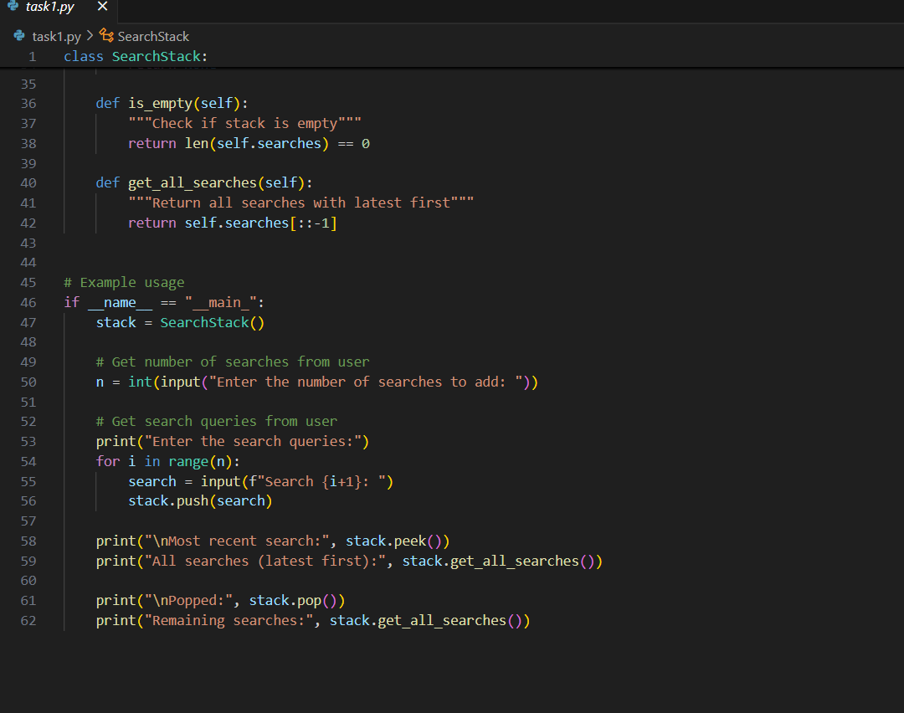

Task2:
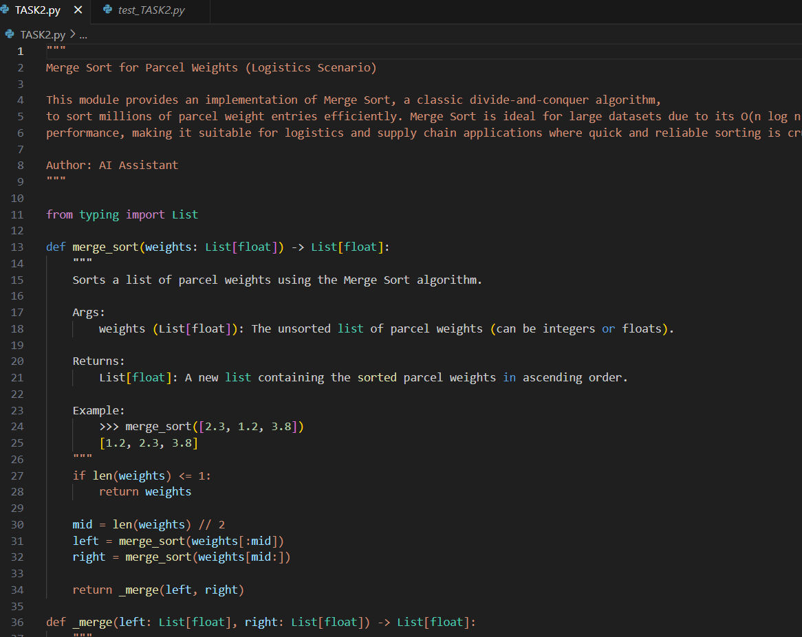
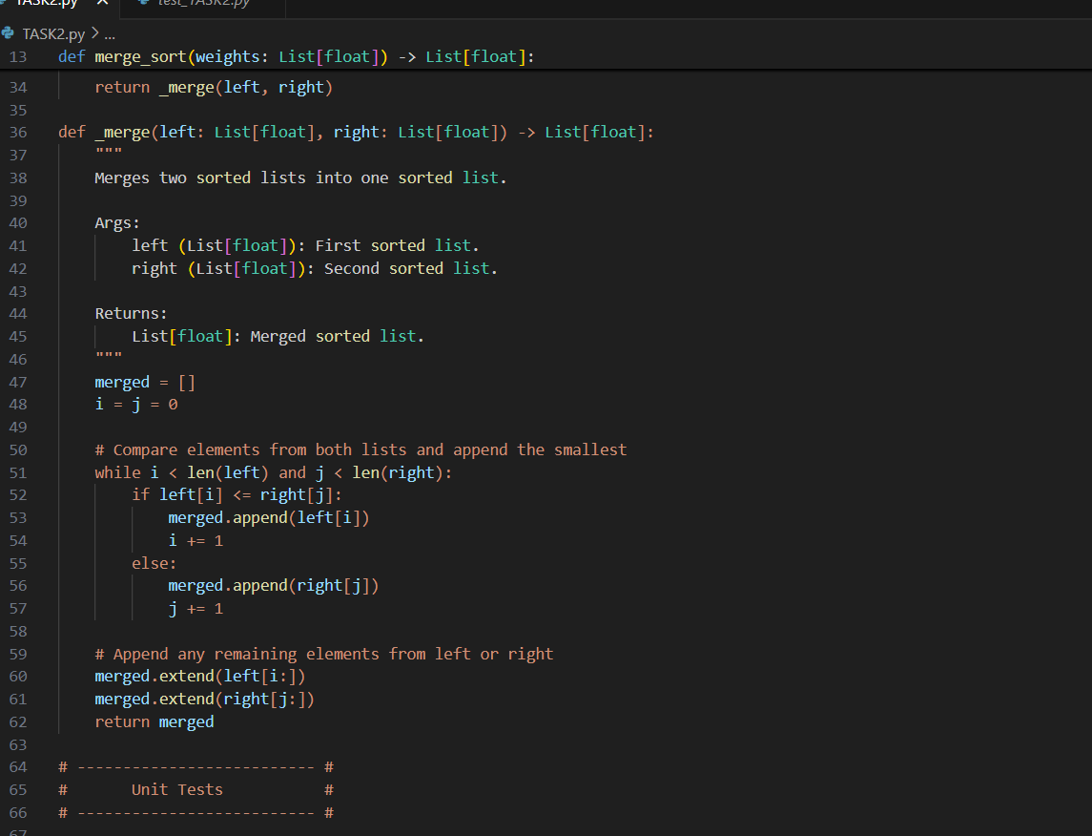

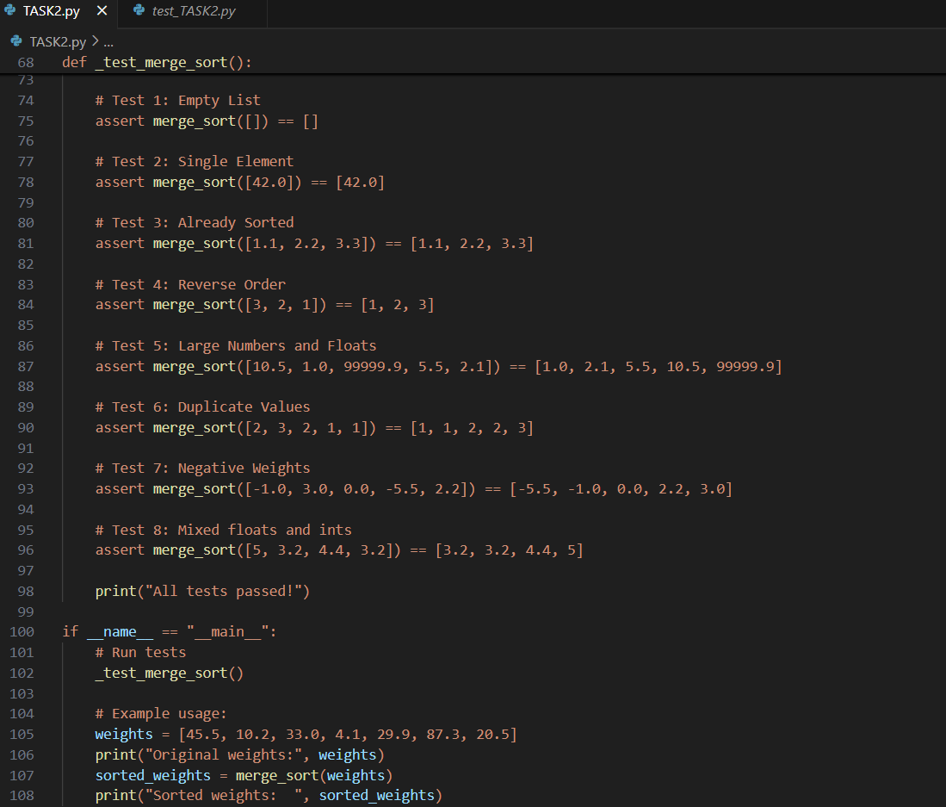

Task2.1: